Sherri Terao, EdD, IFECMH Specialist, RPFM, Director, Behavioral Health Services
Courtney Gray, Executive Director, Quality Management
Hung Nguyen, MS, Division Director, Quality Improvement

QUALITY ASSURANCE & PERFORMANCE IMPROVEMENT (QAPI) WORK PLAN 23

2022-23 Quality Assurance & Performance Improvement (QAPI) Workplan for The County of Santa Clara Behavioral Health Services Department (CSCBHSD)
Contents
Vision 2
Mission 2
Values 2
Purpose 2
Guiding Principles 2
Strategic Priorities 3
Scope 4
QAPI Plan 6
Governance and Leadership 6
Executive Team 6
Quality Management Division 6
BHQIC/System of Care (SOC) Committees 6
Learning Partnership Training (LP) 6
Network Management 6
Clinical Practice Guideline Manual 7
Feedback, Data Systems, and Monitoring 7
Performance Improvement Projects 7
Systematic Analysis and Systemic Action 8
Communication 8
Evaluation 9
Current QI Projects and Goals 10
Access to Care 10
Timeliness 13
Beneficiary Engagement/Outcomes 23
Performance Improvement Projects (PIPs) 29
Glossary 30
References 30
Appendix I- Timeliness and Engagement Graphs ….………………………………………………………………………………………..31
Appendix II- Grivenece and Appeal data ...………………………………………………………………………………………………………37

Vision
The public behavioral health system is successful in helping to ensure that all residents in need of public behavioral health services are:
- Physically and emotionally healthy happy and thriving
- In a safe and permanent living situation
- Part of a loving and supportive social network
- Involved in meaningful school, work activities
- Safe from harm from the environment or others

Mission
To assist individuals in our community affected by mental illness and serious emotional disturbance to achieve their hopes, dreams and quality of life goals. To accomplish this, services must be delivered in the least restrictive, non-stigmatizing, most accessible environment within a coordinated system of community and self-care, respectful of a person's family and loved ones, language, culture, ethnicity, gender and sexual identity.

Values
We believe without reservation:
- All people have the right to behavioral health and well being
- All people must be treated with fairness, respect and dignity in a culturally and linguistically competent way
- With effective treatment and support, recovery from mental illness is achievable
- Consumers will actively participate in their own recovery and treatment goal
- Consumers and their families will be at the center in development, delivery, implementation and evaluation of their treatment
- The system of care must have a structure and process for ensuring access to needed services for potential and current consumers
- All people must have access to the highest quality and most effective integrated services

Purpose
The purpose of QAPI in the County of Santa Clara is (CSC) to take a proactive approach to continually improve the way we care for and engage with our beneficiaries, family members, caregivers, and other community partners so that we may realize our vision. To do this, all employees will participate in ongoing QAPI efforts which support our mission.

Guiding Principles
- Guiding principle #1: CSCBHSD uses quality assurance and performance improvement to make decisions and guide our day-to-day operations.
- Guiding principle #2: The outcome of QAPI in CSCBHSD is to improve the quality of care and the quality of life of our beneficiaries.
- Guiding principle #3: In the CSCBHSD, QAPI includes all employees, all departments, and all services provided.
- Guiding principle #4: QAPI focuses on systems and processes, rather than individuals or specific programs. The emphasis is on identifying system gaps rather than on blaming individuals.
- Guiding principle #5: CSCBHSD makes decisions based on data, which includes the input and experience of beneficiaries (past and present), family members, caregivers, community partners, and other stakeholders.
- Guiding principle #6: CSCBHSD sets goals for performance and measures progress toward those goals.
- Guiding principle #7: CSCBHSD supports performance improvement by encouraging our employees to support each other as well as be accountable for their own professional performance and practice.
- Guiding principle #8: CSCBHSD has a culture that encourages, rather than punishes, employees who identify errors or system breakdowns.

Strategic Priorities
Strategy 1: Ensure Medi-Cal Beneficiaries are Provided Timely Access to High Quality Services
- Objective 1 (Access): Streamlining of Phone Numbers and Implementation of 988
- Objective 2 (Timeliness): Improve Behavioral Health Call Center (CC) Response Time
- Objective 3 (Access): Expand Same Day Access (SDA)
- Objective 4 (Access): Implement Direct Referral to Substance Use and Mental Health Treatment for Patients Discharged from EPS
Strategy 2: Be Proactive in Addressing Ongoing and Emerging Needs from COVID-19
- Objective 1: Increase the Number of Social Detoxification Beds to Address the Increasing Number of Individuals with Severe Substance Use
- Objective 2: Program Redesign and Contracts Flexibilities
  - Expansion of CYF Services to Address Ongoing and Emerging COVID-19 Needs
  - Expansion of AOA Services to Address Ongoing and Emerging COVID-19 Needs
- Objective 3: Refine and Maintain a Behavioral Health System of Care for Individuals and Families Experiencing Homelessness
- Objective 4: Maintain a Comprehensive Behavioral Health System of Care for Individuals Involved in the Criminal Justice System and Exiting Jail
Strategy 3: Increase Permanent Housing, Temporary Shelter and Treatments
- Objective 1: Housing Stabilization Expansion
- Objective 2: Transitional Housing Expansion
- Objective 3: Permanent Supportive Housing Expansion
- Objective 4: Temporary Housing, Shelter and Treatment Expansion
- Objective 5: Streamlining Data Collection and Policy Changes

Strategy 4: Develop Innovative Solutions to Address Professional Workforce Shortages
- Objective 1: Promotion of Public Behavioral Health as a Career Path
- Objective 2: Implement Competitive Rate Structure to Improve Hiring and Retention of Difficult to Fill Clinical Positions to Maintain Network Adequacy
- Objective 3: Improve Sourcing of Candidates for Vacant Clinical Positions
- Objective 4: Increase the Number of Clinical Staff Trained at Different Levels of Co-Occurring Practice (e.g., Informed, Capable and Enhanced)
- Objective 5: Expand, Enhance and Increase Sustainability of Peer Support Services through Participation in the CalMHSA Medi-Cal Peer Certification Program
Strategy 5: Strengthen Infrastructure to Support Integrated Managed Care Delivery System Aligned with CalAIM
- Objective 1: Work with Netsmart to implement Current Procedural Terminology (CPT), update contract boilerplates, develop CPT code training plan, policies and procedures to implement Intergovernmental Transfer (IGT) Protocols
- Objective 2: Implement standardized screening and transition tools, revise documentation standards, and provide guidance and training on new behavioral health policies.
- Objective 3: Establish direct data exchange with Managed Care Plans, work with Netsmart to implement Fast Healthcare Interoperability Resources (FHIR) application programming interface (API), map data elements to the United States Core Data for Interoperability (UCSDI) standard set.

Scope
The scope of the QAPI program encompasses all segments of care and services provided by CSCBHSD that impact clinical care, quality of life, beneficiary choice, and care transitions with participation from all divisions throughout the department. CSCBHSD has adopted a continuous quality improvement model for producing improvement in essential service and clinical areas. This model encompasses a systematic series of activities, organization-wide, which focuses on improving the quality of identified key systems, services, and administrative functions.
The overall objective of the quality improvement process is to ensure that quality is built, measured consistently, interpreted, and articulated into the performance of the BHSD functions. The objective is met through a commitment to quality from the administration, Quality Improvement (QI) staff, beneficiaries, family members, and both contracted and county providers. The quality improvement process is incorporated systematically into all service areas of CSCBHSD. It is applied when examining the care and services delivered by the CSCBHSD network of providers, programs, and facilities.

Segments of Care | Services Rendered
Clinical Care Services | We provide comprehensive clinical care via outpatient, residential, and urgent and emergent services, to beneficiaries with behavioral health needs. All care is person-centered and recovery-oriented, focused around choice and individualized treatment plans. We strive to meet each beneficiary’s goals of care, including developing and executing a transitional plan for discharge to lower levels of care or exiting the system, all together. Services shall be provided in the least restrictive setting and shall be consistent with the goals of recovery and resiliency, learning and development, and enhanced self- sufficiency.
Peer Support | Through shared understanding, respect, and mutual empowerment, we provide peer support services and training that focuses on supporting people to become and stay engaged in the recovery process and reduce the likelihood of relapse.
Prevention and Early Intervention | Through services provided, we expect to create improvements in a range of life stages and domains by preventing and reducing the incidence, prevalence and severity of mental illness and substance use, as well as the reduction of stigma and discrimination, particularly in high-risk areas where overburdened and underserved individuals and families are impacted.
Medication Services | We provide supervision and collaborate with the medical and nursing teams throughout the County of Santa Clara by reviewing, dispensing, and monitoring medication effectiveness to ensure therapeutic goals are maintained for every beneficiary.
Maintenance and Cleanliness | We provide comprehensive building safety, repairs, and inspections to ensure all aspects of safety are enforced, assuring the safety and well-being for each beneficiary, visitor, and staff who enters any County facility. We provide and ensure that all health, sanitation, and OSHA requirements are met through regular cleaning, disinfection, and sanitation of all aspects of the building. We complete site reviews and certifications of contract agencies to ensure appropriateness of site support.
Evaluation and Analytics | Utilizing data from CSCBHSD’s electronic health record (and other systems), we provide support through analytics and reporting of data collected by the entire behavioral health care system to help the system make informed data-driven decisions.
Administration and Review | We align all business practices to ensure every beneficiary has individualized care, and we work to support the providers with the resources and equipment to meet the care goals of those we care for.

The QAPI program at CSCBHSD aim for safety and high quality with all clinical interventions while emphasizing autonomy and choice in daily life for beneficiaries (or beneficiary’s agents), by ensuring our data collection tools and monitoring systems are in place and are consistent for a proactive analysis. We will utilize the best available evidence (such as data from myAvatar and Unicare, national benchmarks, published best practices, clinical guidelines, etc.) to define and measure our goals.

QAPI Plan
The QAPI plan guides performance improvement efforts. This is a living document that is continually refined and revisited. The overarching goals of the QAPI include:
- Increase beneficiary satisfaction and quality of care
- Increase efficiencies in administrative processes
- Strengthen the beneficiary experience of care and key beneficiary protections
- Reduced rates of hospitalization and 24-hour services, and use of emergency and urgent care services

Governance and Leadership
CSCBHSD is committed to improving the quality of all its services, processes, and programs; thereby, the Quality Improvement Team (QI Team) delineates the structures and methods used to monitor and evaluate these improvements. An array of teams and committees within and affiliated with the QI Team provide structure for the quality management and oversight responsibilities of the organization. These include, but are not limited to:

- Executive Team
- Quality Management Division
- Behavioral Health Quality Improvement Committee (BHQIC)
- System of Care (SOC)
- Learning Partnership training (LP)
- Network Management
- Clinical Practice Guidelines Manual

Collectively, these entities provide information and evaluation of current processes, identify areas for improvement, and assist with the department complying with state and federal mandates related to behavioral health services.
The QI Team ultimately responsible for overseeing the BHQIC, which advises and reviews the QAPI. The QI Division Director has direct oversight responsibility for all functions of the BHQIC and reports directly to the Quality Management Director, an Executive Team representative. The BHQIC is ultimately responsible for assuring compliance with federal and state requirements and continuous improvement in quality of care and customer satisfaction.
The QAPI approach at CSCBHSD will also be communicated to consultants, contractors, and collaborating agencies, to make them understand that they each have a role in the QAPI plan.

Executive Team
The Executive Team (ET) has primary responsibility for the quality of service to beneficiaries. The ET is responsible for responding to recommendations from the QI Team and BHQIC and identifying and initiating quality improvement projects. The ET consists of BHS Director, BHS Deputy Directors (clinical and managed care), and Directors within multiple departments. These entities assure these projects promote Quality Management and the QAPI.
The Executive Team of CSCBHSD will develop a culture that involves leadership seeking input from staff, beneficiaries, and their families and/or representatives. This governing body assures adequate resources exist to conduct QAPI efforts. This includes designating one or more persons to be accountable for QAPI; developing leadership and department-wide training on QAPI; and ensuring staff time, equipment, and technical training as needed.

Quality Management Division
Quality Management represents an amalgamation of existing infrastructure that is coming together through the Behavioral Health Integration initiative, which is underway. BHSD’s Executive Team, along with the multi-agency Behavioral Health Quality Improvement Committee (BHQIC) and System of Care (SOC) Committees, have the shared responsibility to arrange improvement priorities with the agency vision and oversee their conduct to advance the organizations mission.
The Quality Management Division will provide the staffing and infrastructure for a wide range of quality management activities, including utilization management and authorization, decision support and measurement, quality assurance and auditing, analytics and reporting, and research and evaluation. Quality Management staff will provide critical quality improvement support to both the ET and the BHQIC and SOC Committees.

BHQIC/System of Care (SOC) Committees
The BHQIC and SOC Committees have senior and clinical leaders from the county, the community, and contracted agencies. They guide the development of each year's QAPI and oversee the conduct of the work plan. Each committee meets throughout the year and regularly reviews performance learning measures, workgroup progress, and generally inform and guide projects to achieve QI objectives.

Learning Partnership Training (LP)
LP is a resource offering training on various topics and principles that are an integral part of professional development at CSCBHSD. LP focuses on fundamental concepts for all county and stakeholder staff. These focus areas may include training specific to billing and documentation or clinical focus, such as evidence-based practices utilized in treatment programs. The overall goal of LP is to assure that training leads to skill development necessary to support the improvement of beneficiary’s care throughout the system of care.

Network Management
BHSD’s network management team portrays an essential part, and its overarching functions is to ensure that network resources are effectively made available to beneficiaries. Furthermore, to assure contract agencies aptitude successful participation in the network of providers. Understanding the network's functions and operational baseline helps with problem-solving whenever QI objectives are challenging to achieve. These functions are proactively implemented using contract monitoring but also reactively observed to ensure goals are achieved.

Clinical Practice Guidelines Manual
Developed by the Practice Standards Workgroup, the Clinical Practice Guidelines Manual integrates recovery-oriented and person-centered best practices with regulatory requirements. It helps to align clinical coaching/supervision and training activities, so they increasingly unite around the needs of beneficiaries – while supporting compliance, reimbursement, and productivity.

Feedback, Data Systems, and Monitoring
CSCBHSD will put in place systems to monitor care and services, drawing data from multiple sources. Feedback systems will actively incorporate input from staff, beneficiaries, families, and others as appropriate. It will include using performance indicators to monitor a wide range of care processes and outcomes and reviewing findings against benchmarks and/or goals the Department has established for performance. It also includes tracking, investigating, and monitoring adverse events every time they occur, and action plans implemented through the plan, do, study, act (PDSA) cycle of improvement to prevent recurrences.
The QI Team in partnership with the BHQIC and other relevant partners at CSCBHSD will decide what data to monitor routinely. Areas to consider may include, but not be limited to, the following examples:
- Clinical care areas, including use of evidence-based practices
- Medications (e.g., those that require close monitoring, antipsychotics, narcotics)
- Complaints from beneficiaries and families
- Hospitalizations and other service use
- Beneficiary satisfaction
- Care plans, including ensuring implementation and evaluation of measurable interventions
- State audits, reviews, and survey results and deficiencies
- Business and administrative processes (e.g., financial information, staff turnover, staff competencies, and staffing patterns).

Targets for performance in the areas that are being monitored will be set by the QAPI team. The target will usually be stated as a percentage.
Benchmarks for performance such as the State and CSCBHSD’s performance measures, Monthly Medi-Cal Eligibility Data System Eligibility, ShortDoyle/Medi-Cal (SDMC) approved claims, and Inpatient Consolidation file (IPC) will be used to monitor progress.

Performance Improvement Projects
The QI Team and BHQIC at CSCBHSD will review our sources of information to determine if gaps or patterns exist in our systems of care that could result in quality problems; or if there are opportunities to make improvements.
Examples of potential areas to consider when reviewing data include:

- Ability to impact the problem and available resources
- Access to care
- Aspects of care occurring most frequently or affecting large numbers of residents
- Beneficiary and family satisfaction and/or expectation trends
- Beneficiary care plans and service delivery for documented progress towards specified goals
- Critical incidents
- CSI and overall NACT data for problem patterns
- Diagnoses associated with high rates of recidivism if not treated in accordance with accepted standards of care, including evidence-based practices (EBPs)
- EBPs and expected outcomes
- Incident report trends
- Issues identified from demographic and epidemiological data, including penetration rates
- Near misses
- State performance measures and Approved Claims data
- Patterns of ER/EPS visits and/or hospital use
- Re-admission rates (outpatient and hospitalization)
- Regulatory requirements
- Safety concerns
- Service volume and clinical outcomes
- State audit, review, and/or survey results and plans of correction
- Survey deficiencies scope and severity
- Timeliness of services
- Trends in complaints

Based on the result of the review of information, the QI Team at CSCBHSD will prioritize opportunities for improvement, taking into consideration the importance of the issues (high risk, high frequency, and/or problem prone). The QAPI team will determine which problems will become the focus for a Performance Improvement Project (PIP).
Depending on the PIP to be started, the QI Team will charter a PIP Team who is entrusted with a mission to investigate a problem area and come up with plans for correction and/or improvement to be implemented.

Systematic Analysis and Systemic Action
CSCBHSD uses a systematic approach to determine when in-depth analysis is needed to fully understand the problem, its causes, and implications of a change. CSCBHSD applies a thorough and highly organized/structured approach to determine whether and how identified problems may be caused or exacerbated by the way care and services are organized or delivered. CSCBHSD’s approach comprehensively assesses all involved systems to prevent future events and promote sustained improvement. CSCHBSD also has developed policies and procedures regarding expectations for the use of root cause analysis when problems are identified. This element includes a focus on continual learning and continuous improvement.

Communication
At a minimum, the executive leadership will report annually on the status of the current QAPI plan, the proposed QAPI plan, and goals for the coming year. This report will be made available to:

- County of Santa Clara Board of Supervisors
- Entire management team of CSCBHSD
- Staff
- Beneficiary and Family councils (e.g., Behavioral Health Board, NAMI)
- CalEQRO
- Other stakeholders, as designated

At a minimum, the QI Team will report the progress on the established QAPI goals, PDSA cycles, and current data trends to the following:
- CSCBHSD executive leadership
- CSCBHDS division directors and senior managers
- BHQIC

Evaluation
At a minimum, the executive leadership and division management teams, along with the assistance of the QI Team and BHQIC, will conduct a facility-wide systems evaluation using a QAPI Self-Assessment. The team will thoughtfully and thoroughly consider the progress made in the last year toward achieving the designated QAPI goals and current status of measurement in meeting and sustaining the performance indicators. Other factors to consider will be current trends in the behavioral health industry as well as strategic goals for the Department. Gaps in systems and processes will be identified and addressed in the coming year’s QAPI plan. The QI Team and BHQIC will complete an evaluation of data at least every six (6) months, preferably every quarter, depending on data availability.

Current QI Projects and Goals

Access to Care
Topic & Goal | Objective(s) | Outcome Summary and Progress | Activities to Improve Outcomes & Current Status/Next Steps | Responsible Party/ies
- Provider Network Adequacy  CSC MHP will maintain and monitor provider FTE to meet our current need as determined by DHCS Network Adequacy Oversight Section (NAOS)  Adult Psychyatry-13.59  Children and Youth Psychyatry-9.33  Adult SMHS-125.04  Children and Youth SMHS-241.54  Division: MH | - County programs and contracted agencies will submit 274 data monthly to track changes/additions to the provider network.  - BHSD will update Provider Directory quarterly per DHCS requirement.  - BHSD will work with county programs and contracted providers to be in compliance with network adequacy requirements. | BHSD has previously tracked the provider ratios through the Network Adequacy submission data. Since BHSD’s transition to the 247 monthly tracking, the process is now being monitored through BHSD’s Quality Assurance Department. The Quality Improvement team is currently doing a quarterly point in time checks on the 274 data to ensure that the FTE standards are being met. For all four quarters in FY23 BHSD has displayed above adequate staffing for the MHP Network.  Service Category # of Full Time Equivalency (FTE) Providers Needed to Meet the Ratio Standard # of FTE Providers Reported 274  Q1 Q2 Q3 Q4  Psychiatry Provider Capacity – Adults 13.59 32.6 No Data 34.1 35.17  Psychiatry Provider Capacity -Children/ Youth 9.33 15.9 10.8 12.97  Outpatient SMHS Provider Capacity – Adults 125.04 484.2 499.8 507.46  Outpatient SMHS Provider Capacity -Children/ Youth 241.54 734.3 695.1 703.46  Data Source: 274 data- see appendix for data tables | BHSD is currently trying to refine the 274 data collection process. QI will be submitting the NACT upon request from DHCS. Staffing demands is an ongoing issue throughout behavioral health and will continue to be monitored by BHSD. | - Quality Improvement Division  - Quality Assurance Division  - Analytics & Reporting  - Service Delivery
- Provider Linguistic Capacity-  Ensure services are provided in the client's preferred language by utilizing bilingual staff, qualified interpreters, and/or language line.  Division: MH | - Ensure that preferred language is offered and documented at each service indicating preferred language.  - Ensure that when clients request a preferred language utilize qualified interpreters, language line or bilingual staff to provide service in preferred language. Document at each service if client declines preferred language service. | There has not been a significant change on the number of clients served by languages. BHSD continues to have sufficient staffing to provide bilingual services in the clients preferred languages.  FY 22  Language %Providers % Active Clients  Chinese 4% 0.9%  Farsi 1% 0.5%  Spanish 30% 13.4%  Tagalog 1% 0.2%  Vietnamese 5% 2.4%  Other Languages 3% 15.2%  FY 23  Languages % Providers % Active Clients  Q1 Q2 Q3 Q4 Q1 Q2 Q3 Q4  Chinese 3% 3% 3% 3.5% 0.9% 0.4% 0.8% 0.8%  Farsi 1% 1% 1% 0.7% 0.3% 0.1% 0.3% 0.4%  Spanish 30% 28% 28% 27.9% 14.9% 15.4% 17.6% 13.6%  Tagalog 1% 1% 1% 0.7% 0.1% 0.1% 0.2% 0.2%  Vietnamese 5% 6% 6% 5.7% 2.8% 2.4% 5.4% 3.0%  Other Languages 3% 2% 2% 2.1% 1.8% 1.2% 1.9% 1.7%  Data Source: myAvatar service reports, BHSD Network Adequacy Certification Tool | BHSD plans to narrow down reports to emphasize language gaps in certain geographic areas. BHSD is also providing access to the language line and monitoring its usage. | - Quality Assurance Division  - Quality Improvement  - Service Delivery
- Access to Specialty Mental Health Services (SMHS) – 24/7 Access Line-Test Calls  BHSD will conduct 18 test calls per quarter, during and after business hours, a minimum of 14 calls will be conducted in a language other than English. Test calls will be appropriately logged 96% of the time.  Division: MH | - Conduct 18 test calls per quarter using test call scripts/worksheets that capture all required elements.  - Ensure at least 14 test calls per quarter are conducted in a language other than English to test capacity to link beneficiaries with an interpreter as needed.  - Ensure that test calls are conducted both during and after business hours to assess Call Center services.  - Review adherence to test call requirements on a quarterly basis (including appropriate logging of test calls) and provide feedback and training to Call Center staff. | For FY 23 BHSD Test Calls data has significantly improved since implementation of the PIP, with the largest percent logged in Q1 when BHSD first implemented the PIP. The amount of test calls has fluctuated quarterly. FY 22 had an average of 55% Test Call logged, in FY 23, BHSD increased the average Test Calls logged to 72%. BHSD has still not met the goal 96% logged.  FY22 Total Test Calls placed Total Non-English Calls Total % Calls Logged  Goal 18 calls/ quarter 14 calls/ quarter 96%  Q1 12 5 67%  Q2 22 18 59%  Q3 14 14 50%  Q4 16 16 44%  FY23 Total Test Calls placed Total Non-English Calls Total % Calls Logged  Goal 18 calls/ quarter 14 calls/ quarter 96%  Q1 20 20 84%  Q2 23 20 60%  Q3 19 13 74%  Q4 15 14 53%  FY23 Cumulative 77 67 72%  Data Source: Call Center Call log, Test Call Reports, 24_7 Access Line Test Call Report | BHSD will reevaluate the number of test calls needed for this measure. QI team will work with Call Center and CCWP team to ensure an appropriate and adequate number of test calls are being performed quarterly. | - Call Center  - Cultural Communities Wellness Program  - Quality Improvement
- Access to Substance Use Services – 24/7 Access Line-Test Calls-  BHSD will conduct 10 test calls per quarter, during and after business hours, a minimum of 8 calls will be conducted in a language other than English. Test calls will be appropriately logged 96% of the time.  Division: SUTS | - Conduct 10 test calls per quarter using test call scripts/worksheets that capture all required elements.  - Ensure at least 14 test calls per quarter are conducted in a language other than English to test capacity to link beneficiaries with an interpreter as needed.  - Ensure that test calls are conducted both during and after business hours to assess Call Center services.  - Review adherence to test call requirements on a quarterly basis (including appropriate logging of test calls) and provide feedback and training to Call Center staff. | This is a newer measure for BHSD. SUTS Test Calls are now being tracked quarterly with the same report that is used for the MHP. The SUTS test call report tracks similarly to the MH report. Q1 had the highest percentage of test calls logged with 87.5%, which still falls short from the goal. BHSD will need to increase the number of test calls per quarter. Log percentage still needs to be increased.  FY 23  FY23 Total Test Calls placed Total Non-English Calls Total %Calls Logged  Goal 10calls/ quarter 8calls/ quarter 96%  Q1 9 9 87.5%  Q2 6 6 50%  Q3 2 2 50%  Q4 2 1 50%  FY23 Cumulative 19 18 63%  Data Source: Call Center Call log, Test Call Reports, 24_7 Access Line Test Call Report | BHSD QI will meet with the CCWP to increase the number of test calls being placed for the SUTS access line. | - Call Center  - Cultural Communities Wellness Program  - Quality Improvement

Timeliness
Topic & Goal | Objective(s) | Outcome Summary and Progress | Activities to Improve Outcomes & Current Status/Next Steps | Responsible Party/ies
- Timely Access to Services- First Offered Appointment  80% of new beneficiaries requesting mental health services with be offered their 1st appointment within 10 business days  Division: MH | - Collect First Offered appointment data monthly from CCP’s and County Clinics  - Evaluate and analyze monthly data and report out to the system of care  - Provide needed data for annual Network Adequacy reporting | There has been no significant improvement with beneficiaries being offered their first appointment within 10days when entering the mental health system of care when comparing FY 22 to FY23. While the percentage of beneficiaries has remained the same, there has been a slight increase in the mean and median number of days between beneficiary request for services. There is also a noted decrease in number of referrals systemwide for FY 23.  In FY 23 Q4 had the highest percent of reaching beneficiaries being offered their initial appointment at 57%.  Graphs displaying quarterly performance can be found in the Appendix  Initial request to First Offered assessment  Measure Systemwide Adult Children And Youth Foster Youth  End of FY 22 Cumulative Total # of Referrals 13220 6283 6937 201  Number of Clients had first offered assessment within 10 days 6454 2779 3675 100  Percent within 10 business days 49% 44% 53% 50%  Average # of days/ Median # of days 11.24 days / 7 days 10.4 days/ 7 days 11.8 days/ 7 days 10.8 days/ 8 days  Initial request to First Offered assessment  Quarter Measure Systemwide Adult Children And Youth Foster Youth  End of FY 23 Cumulative Total # of Referrals 12459 5854 6605 109  Number of Clients had first offered assessment within 10 days 6098 2640 3458 62  Percent within 10 business days 49% 45% 52% 57%  Average # of days/ Median # of days 12.6 days/ 8 days 12.8 days/ 8 days 12.4 days/ 8 days 10 days/ 7 days  Data Source: Referral Extract from MyAvatar, monthly TADT spreadsheets | Timely Access continues to be a major focus for BHSD. In FY 23 BHSD piloted Same Day Assessment and a Warm Hand-off between Call Center and Referral agency to help with meeting the Timely Access standards. In FY 24 BHSD will roll out the Warm Hand-off system wide. Increasingly, throughout the system providers are trying to implement same day access. | - Quality Improvement Division  - Clinical Division Leadership (Division Directors, Contract Monitors)  - Call Center
- Timely Access to Services- First Service Rendered  80% of new beneficiaries requesting mental health services will receive their first service within 10 business days  Division: MH | - QI will monitor monthly referral  - QI will compare referral data with service data to ensure standards are being met  - Provide needed data for Annual Network Adequacy reporting | Timely Access for a beneficiary to receive their first service has declined across the system of care from FY 22 to FY 23. The mean and median increasing from an average of 11.8 days to 14.8 days systemwide.  In FY 23 and FY 22, the percentage of beneficiaries receiving their first service within 10 business days tracks between 20 and 40%  Graphs displaying quarterly performance can be found in the Appendix  First request for service to first delivered service -FY22  Quarter Measure Systemwide Adult Children And Youth Foster Youth  End of FY 22 Cumulative Total # of Referrals 13220 6293 6937 201  Number of Clients had first delivered service within 10 days 4514 1904 2532 70  Percent within 10 business days 34% 30% 36% 35%  Average # of days/ Median # of days 11.8 days/ 8 days 11.3 days/ 8 days 12.1 days/ 9 days 13.7 days/11 days  First request for service to first delivered service -FY23  Quarter Measure Systemwide Adult Children And Youth Foster Youth  End of FY 23 Cumulative Total # of Referrals 12459 5854 6605 109  Number of Clients had first delivered service within 10 days 3836 1707 2129 36  Percent within 10 business days 31% 29% 32% 33%  Average # of days/ Median # of days 14.8 days/ 10 days 14 days/ 9 days 15.3 days/ 11 days 14 days/10 days  Data source: Referral extract from myAvatar, Service report from myAvatar | BHSD will continue to track and monitor this measure. As Same day assessment is implemented by more programs, BHSD hopes that this number will improve. QI will explore other Quality Improvement projects that may assist with better performance in this measure. | - Quality Improvement Division  - Clinical Division Leadership (Division Directors, Contract Monitors)  - Call Center
- Timely Access to Services- First Offered Psychiatry  80% of new beneficiaries will be offered a psychiatric appoint within 15 business days from request.  Division: MH | - QI will collect psychiatric request and offer dates from CCP’s and County Clinics  - QI will analyze this data on a monthly basis.  - Provide needed data for Annual Network Adequacy reporting | BHSD began refining psychiatry tracking in mid FY 22, so FY 22 numbers are not fully representative. In FY 23 only 36% of beneficiaries were reported to have been offered a psychiatry appointment within 15 business days. It seems that request for psychiatry appointments is under reported across the system of care.  Graphs displaying quarterly performance can be found in the Appendix  Beneficiary request for to non-urgent psychiatry to first offered psychiatry appointment -FY 22  Quarter Measure Systemwide Adult Children And Youth Foster Youth  End of FY22 Cumulative Total # Clients who requested Psychiatry appt 956 662 294 12  Number of Clients had first offered psychiatry appointment within 15 days 477 299 178 4  Percent within 15 business days 50% 45% 61% 33%  Average # of days/ Median # of days 17.3 days/ 14 days 20.9 days/ 18 days 15.6 days/ 13 days 17.9 days/ 20 days  Beneficiary request for to non-urgent psychiatry to first offered psychiatry appointment -FY 23  Measure Systemwide Adult Children And Youth Foster Youth  End of FY23 Cumulative Total # Clients who requested Psychiatry appt 2045 1358 687 14  Number of Clients had first offered psychiatry appointment within 15 days 744 487 257 7  Percent within 15 business days 36% 36% 37% 50%  Average # of days/ Median # of days 20.7 days/ 14 days 22.4 days/ 17 days 16 days/ 10 days 13 days/ 9 days  Data Source: Referral Extract from MyAvatar, monthly TADT spreadsheet | In FY 23 QI developed a Psychiatry Tracking policy to help define the process of collecting psychiatry data. QI will continue to work with CCP’s and County Clinics to collect beneficiary request more accurately for psychiatry services. | - Quality Improvement Division  - Service and Delivery  - Call Center  - Psychiatry
- Timely Access to Services- First Rendered Psychiatry service  80% of Beneficiaries will receive a psychiatric service within 15 business days from their initial request.  Division: MH | - QI will collect beneficiary request for psychiatry monthly from CCP’s and County Clinics  - QI will analyze beneficiary request for psychiatry  - Provide needed data for Annual Network Adequacy reporting | FY 23 had significantly longer time to psychiatry service than in FY 22. Mean and median increased days increase as well. In Q4, Foster Youth was the only population that exceeded the goal at 100% (N=2).  Graphs displaying quarterly performance can be found in the Appendix  Beneficiary request for to non-urgent psychiatry to first offered psychiatry appointment -FY 22  Quarter Measure Systemwide Adult Children And Youth Foster Youth  End of FY 22 Cumulative Total # Clients who requested Psychiatry appt 956 662 294 12  Number of Clients had first offered psychiatry appointment within 15 days 477 299 178 4  Percent within 15 business days 50% 45% 61% 33%  Average # of days/ Median # of days 17.3 days/ 14 days 20.9 days/ 18 days 15.6 days/ 13 days 17.9 days/ 20 days  Beneficiary request for to non-urgent psychiatry to first psychiatry service delivered -FY 23  Quarter Measure Systemwide Adult Children And Youth Foster Youth  End of FY 23 Cumulative Total # Clients who requested Psychiatry appt 2045 1358 687 14  Number of Clients had first psychiatry service within 15 days 417 289 128 5  Percent within 15 business days 20% 21% 19% 36%  Average # of days/ Median # of days 26.2 days/ 20 days 27 days/ 21 days 24 days/ 16.5 days 20 days/ 9 days  Data Sources: TADT, myAvatar service reports | BHSD will work on refining the psychiatry tracking process. The psychiatry request seem significantly under reported. QI will work with CCP’s and providers | - Quality Improvement Division  - Service and Delivery  - Call Center  - Psychiatry
- Timely Access to Services- Urgent appointments-  80% of Beneficiaries requesting and urgent appointment will receive services within 48 hrs. (no prior authorization required) / 96 hours (prior authorization required)  Division: Mental Health | - Behavioral Health Urgent Care will track all walk-in Urgent appointments  - QI will collect and analyze the data from Urgent Care with Service data | In both Fiscal Years, BHSD has exceeded that goal for this measure. Throughout all of FY 23 BHSD met this goal 100%.  Service request for urgent appointment to actual encounter -FY 22  End of FY 22 Cumulative Total # Urgent appointments 3908 3760 148 20  # Urgent appointments met standard within 48 hours 3713 3568 145 19  Percent # Urgent appointments met standard within 48 hours 95% 95% 98% 95%  Average # of Hours/ Median # of Hours .33 hours/ .27 hours .33 days/ .27 hours .32 hours/ .28 hours .26 hours/ .25 hours  Service request for urgent appointment to actual encounter -Table5  End of FY 23 Cumulative Total # Urgent appointments 4066 3906 160 5  # Urgent appointments met standard within 48 hours 4066 3906 160 5  Percent # Urgent appointments met standard within 48 hours 100% 100% 100% 100%  Average # of Hours/ Median # of Hours .40 hours/ .33 hours .40 days/ .33 hours .42 hours/ .33 hours .52 hours/ .47 hours  Urgent Care walk-in log, myAvatar service data | BHSD will begin separating the tracking of Urgent psychiatric appointments and Urgent therapy/intake appointments. | - Quality Improvement Division  - Leadership (Division Directors, Contract Monitors)  - Mental Health Urgent Care
- Timely Access to Post-psychiatric Hospitalization Follow-up  80% of beneficiaries will receive their first follow-up appointment within 7 days after discharge from psychiatric hospitalization.  80% of beneficiaries will receive 4 follow-up appointments within 30 days after discharge from psychiatric hospitalization.  Division: MH | - Monitor:  - Post-discharge outpatient appointment follow-up – 7 days after discharge  - 4 follow-up appointments 30 days Post- discharge  - Send the inpatient/ outpatient reports to the System of Care | There was a slight decrease (37% to 33%) of beneficiaries receiving a follow up appointment within 7 days post psychiatric discharge. The same trend was found for the 4 in 30 measure decreasing from 47% to 42%.  Graphs displaying quarterly performance can be found in the Appendix  Follow-up Service post-psychiatric hospitalization -FY 22  End of FY 22 Cumulative Total Hospital Discharges 1883 1430 453 77  Total Number Follow-up Service delivered within 7 days discharge 701 442 259 49  Percent of delivered services within 7 days 37% 31% 57% 64%  Total Number 4 Follow-up Services delivered within 30 days discharge 876 571 305 58  Percent of delivered services within 30 days 47% 40% 67% 75%  Average Days from discharge to first service 8.0 days/ 3.0 days 9.0 days/ 3.0 days 6.3 days/ 2.0 days 7.1 days/ 1.0 days  Follow-up Service post-psychiatric hospitalization -FY 23  Measure Systemwide Adult Children And Youth Foster Youth  End of FY 23 Cumulative Total Hospital Discharges 2194 1710 484 32  Total Number Follow-up Service delivered within 7 days discharge 720 469 251 21  Percent of delivered services within 7 days 33% 27% 52% 66%  Total Number Follow-up Services delivered within 30 days discharge 930 618 312 26  Percent of delivered services within 30 days 42% 36% 64% 81%  Average Days from discharge to first service 7.72 days/ 3.0 days 8.8 days/ 3.0 days 5.38 days/ 2.0 days 5.4 days/ 1.0 days | BHSD will work on developing reports for tracking hospitalization readmission for review by the utilization review team. Such reports would assist with creating a system for analyzing patterns for readmissions based on demographics and treatment settings. | - Service and Delivery  - QI
- Timeliness of NTP Services  Ensure a minimum of 80% of beneficiary’s have access to NTP dose services within three (3) business days with needed accommodations.  Division: SUTS | - Measure timeliness of first contact with Call Center to initial dose date.  - Analyze and track data  - Provide needed data for Annual Network Adequacy reporting | There was an 32% increase in referrals to NTP in FY 23 (125 to 165). In FY 23 only 21% of those that requested NTP services received a service within 3 business days. The average number of days increased from 9 to 18 days in FY 23. In FY 23, Q3 had the highest number of beneficiaries meeting the standard at 29% with an average of 9 days. Q4 was the lowest at 14% with an average of 18 days.  Graphs displaying quarterly performance can be found in the Appendix  Timeliness of NTP Fiscal Year 2021-22  Adult (N=125) 3 business days Average, business days Median, business days  Q1 40% 7 4  Q2 14% 13 13  Q3 14% 9 8  Q4 31% 7 5  NTP -Timeliness of NTP Services FY 22-23  Measure Systemwide Adult Children And Youth  End of FY 23 Cumulative Total Unduplicated clients had Referrals 165 165 NA  Number of Clients had first NTP dose services within three (3) business days 34 34 NA  Percent within 3 business days 21% 21% NA  Average # of days/ Median # of days 18 days/ 9 days 18 days/ 9 days NA  Data source- myAvatar referral extract, myAvatar service report | BHSD began utilizing the same TADT used by Mental health programs in FY 24. BHSD will begin to report on 1st offered appointments. | - Call Center  - NTP Programming  - QI
- Timeliness to Intake – Outpatient  At least 80% beneficiaries to receive OP SUTS services within 10 business days from date of referral  Division: SUTS | - Timeliness of first contact with Call Center to referral appointment date.  - The interval between the referral/ appointment date in OP to actual intake date (% occur within 10 business days)  - Provide needed data for Annual Network Adequacy reporting | There were more referrals tracked in FY 23. There was also a significant decrease in the percentage of beneficiaries seen within the 10 business days. The mean and median days increased as well. In FY 23 Q2 had the lowest number meeting the standard at 23% it also had the lowest number of referrals, N=900 compared to 1000+ in other quarters.  Graphs displaying quarterly performance can be found in the Appendix  FY22 Adult OP, % (N=1346) Adult OP, mean, business days Adult OP, median, business days Youth OP, % (N=97) Youth OP, mean, business days Youth OP, median, business days  Q1 61% 10 8 74% 6 4  Q2 69% 9 7 53% 10 8  Q3 69% 9 7 63% 9 7  Q4 69% 9 6 54% 14 9  Table 2: Timeliness to Intake -Outpatient - First request for service to first delivered service  Measure Systemwide Adult Children And Youth  End of FY 23 Cumulative Total Unduplicated clients had Referrals 3752 3564 191  Number of Clients had first delivered service within 10 days 1066 1024 42  Percent within 10 business days 28% 29% 22%  Average # of days/ Median # of days 18 days/ 11 days 18 days/ 11 days 23 days/ 15 days  Data source: myAvatar referral extract, myAvatar service data | BHSD began using the TADT in FY24. With the TADT BHSD will be able to determine the reason more easily for delayed access to services. | - Call Center  - Service and Delivery  - QI
- Timeliness to Intake – Residential-  At least 80% of adults receive an intake within 14 calendar days of referral (non-expedited requests)  Division: SUTS | - Timeliness of first contact to completed intake appointment  - Consideration for residential referral UM/UR approval process  - Provide needed data for Annual Network Adequacy reporting | BHSD has continued to not meet the goal of 80% beneficiaries receiving residential service within 14 calendar days. In FY 23 only 23% of beneficiaries received their first intake within 14 days. The average for FY 23 was 26 days.  Graphs displaying quarterly performance can be found in the Appendix  FY22 Adult, % (N=97) Mean Median  Q1 48% 16 15  Q2 43% 17 17  Q3 26% 26 23  Q4 38% 22 21  Timeliness to Intake - Residential  Measure Systemwide Adult Children And Youth  End of FY 23 Cumulative Total Unduplicated clients had Referrals 210 210 NA  Number of Clients had first delivered service within 14 days 67 67 NA  Percent within 14 business days 32% 32% NA  Average # of days/ Median # of days 26 days/ 22 days 26 days/ 22 days NA  Data source: myAvatar referral extract, my Avatar service data |  | - UM/UR Division  - QI  - Service and Delivery

Beneficiary Engagement/ Outcomes
Topic & Goal | Objective(s) | Outcome Summary and Progress | Activities to Improve Outcomes & Current Status/Next Steps | Responsible Party/ies
- Outcomes – Successful Discharges  Increase the number of beneficiaries who successfully discharge to 70% for Adults and 75% for Family and Children.  Division: MH | - Successful discharges are beneficiaries who have discharged from the system after achieving their goal or making substantial progress towards their treatment goals. | BHSD continues to struggle with reaching successful discharges. For FY 23 only 48% of beneficiaries were marked as having successful discharges compared to last fiscal year 53%. Foster Youth is the only population that met the goal of 75%  Graphs displaying quarterly performance can be found in the Appendix  Successful discharge -FY 22  Quarter Measure Systemwide Adult Children And Youth Foster Youth  End of FY 22 Cumulative Total # of Discharges 22009 9592 12417 1187  Number of Successful Discharges 11556 3746 7810 816  Percent Successful Discharges 53% 39% 63% 69%  Successful discharge -FY23  Measure Systemwide Adult Children And Youth Foster Youth  End of FY 23 Cumulative Total # of Discharges 23775 14627 9148 131  Number of Successful Discharges 11448 6001 5447 98  Percent Successful Discharges 48% 41% 60% 75%  Data Source: myAvatar discharge data | BHSD will work on developing effective real-time reports that will address unsuccessful discharges to allow a proactive intervention approach. | - QI Division  - Service and Delivery
- Outcomes- hospital readmissions  Reduce the number of beneficiaries receiving inpatient hospital services who are readmitted within 7 and 30 days to 9%.  Division: MH | - Reduce recidivism rates after inpatient hospitalization.  - Analyze and report data to the system of care. | The rate for beneficiaries being readmitted 7 days after discharge continues to meet the goal of under 9%. After tracking for 30 days, BHSD falls short of the goal with 11% being readmitted.  Graphs displaying quarterly performance can be found in the Appendix  Post-psychiatric hospitalization readmission within 7 days; 30 days -FY22  Quarter Measure Systemwide Adult Children And Youth Foster Youth  End of FY 22 Cumulative Total Hospital Discharges 1883 1430 453 77  Total Number Readmitted within 7 days 67 53 14 4  Percent of readmitted within 7 days 4% 4% 3% 5%  Total Number readmitted within 30 days 172 131 41 12  Percent of readmitted within 30 days 9% 9% 9% 16%  Average Days readmitted/ Median 19.4 days/ 13 days 18.8 days/ 12 days 21.4 days/ 16 days 18.6 days/ 13 days  Post-psychiatric hospitalization readmission within 7 days; 30 days -FY23  End of FY 23 Cumulative Total Hospital Discharges 2194 1710 484 32  Total Number Readmitted within 7 days 101 84 17 1  Percent of readmitted within 7 days 5% 5% 4% 3%  Total Number readmitted within 30 days 252 197 55 2  Percent of readmitted within 30 days 11% 12% 11% 6%  Average Days readmitted/ Median 21 days/ 16 days 19.7 days/ 13 days 27.4 days/ 22.5 days 32 days/ 37 days  Data Source: myAvatar, Healthlink | BHSD will continue to track and report on this goal. | - QI  - Service and Delivery  - Health and Hospital System
- Client Engagement with SMHS – no show rates  Achieve less than or equal to 10% no-show rates to psychiatry and non-psychiatry scheduled SMHS appointments for adults, children/youth and foster youth.  Division: MH | - Monitor no-show rates to scheduled SMHS appointments and achieve rates of 10% or less  - No Show appointment rates – psychiatry appointments – ≤10%  - No show appointment rates – non-psychiatry SMHS appointments – ≤10% | No shows rates achieved less than 10% rates for both psychiatry and non-psychiatry SMHS appointments.  Psychiatry Other SMHS  FY21-22 FY22-23 FY21-22 FY22-23  Adults 8.04% 5.92% 3.04% 1.41%  Children/Youth .85% 4.49% 3.76% 1.67%  Foster Youth 1.33% 4.79% 2.44% 1.17%  Data Source: Unicare, myAvatar | BHSD will monitor quarterly on the percentage of individuals scheduled for clinic intake evaluations who show up for their appointment for both Adults and Youth. | - QI  - Service and Delivery
- Engagement to Services – 4 in 30  80% of clients will receive four (4) face-to-face services within 30 days.  Division: SUTS | - Track the Percentage of outpatient clients receiving four face-to-face sessions in first 30 days | BHSD did not reach this goal in FY 23. All Quarters in FY23 ranged between 30-45% meeting the standard access the system.  Graphs displaying quarterly performance can be found in the Appendix  FY21-22  Adult OP Youth OP  Q1 76% 68%  Q2 82% 55%  Q3 83% 58%  Q4 94% 71%  Engagement Services - Clients had 4+ visits (face to face) in 30 days  Measure Systemwide Adult Children And Youth  End of FY 23 Cumulative Total # Clients had Services in 30 days 4101 3580 521  Number of Clients had 4 face to face services in 30 days 1776 1559 217  Percent Number of Clients had 4 face to face services in 30 days 43% 44% 42%  Data Source: myAvatar service data | BHSD will evaluate and analyze this data more thoroughly | - QI  - Service and Delivery

Performance Improvement Projects (PIPs)

Division | Clinical/ Non- Clinical | Topic | Intervention | Status | Next steps
MH/SUTS | Non-clinical | Improving the 24/7 Access Call Line Efficiency | Implement a more streamlined method and procedure for the quarterly test calls and Call Center logging | Completed | BHSD has implemented this new process.
MH/SUTS | Clinical | Follow-up after ER visit for Substance Use and Mental Health | ER Doctors will send referral to BHSD Navigator program to encourage treatment following ER visit. | In progress | BHSD is currently piloting this process.
MH | Clinical | Increase Timeliness to Services- Warm-Hand-Off | Call Center staff will initiate a warm hand-off with beneficiary upon referral to an agency/ clinic. | Pending | BHSD had success in pilot program. QI is awaiting approval from leadership to implement to entire system of care.
MH | Clinical | Use of MHSA Client Support Services and Re-engagement to improve Outcomes for FSP beneficiaries. | Implement new strategies to engage beneficiaries | On hold | Use of the created codes has been halted. BHSD will explore other ways to potentially increase engagement.
SUTS | Clinical | Pharmacotherapy for Opioid Use Disorder | Use of Peer Mentors to help engage into treatment. | In progress | BHSD is currently piloting this process.
MH | Clinical | Increase Timeliness to Services- Same Day Assessment | Call Center staff will connect beneficiary to referral agency following screening. Agency will engage beneficiary in first service appoint on the same day as call center referral. | In progress | SDA showed some success in the pilot clinic. BHSD is considering implementing SDA in other clinics.

Glossary
TBD

References
- Quality Improvement Organizations, Centers for Medicare & Medicaid Services, Health Services Advisory Group (HSAG): https://www.hsag.com/
- The Centers for Medicare & Medicaid Services. QAPI at a Glance: A Step by Step Guide to Implementing Quality Assurance and Performance Improvement (QAPI) in Your Nursing Home. https://www.cms.gov/Medicare/Provider-Enrollment-and-Certification/SurveyCertificationGenInfo/Downloads/Survey-and-Cert-Letter-13-05.pdf.
- The Centers for Medicare & Medicaid Services. QAPI Process Tool Framework. http://www.cms.gov/Medicare/Provider-Enrollment-and-certification/QAPI/Downloads/ProcessToolFramework.pdf.
- Carolinas Center for Medical Excellence. Atlantic Quality Innovation Network: Action Collaborative for Excellence in Long-Term Care 2014 QAPI Plan.

Appendix I - Timely Access and Engagement Graphs

Mental Health

Substance Use Treatment

Appendix II- Grievance and Appeals Reports
Grievances
DMC-ODS
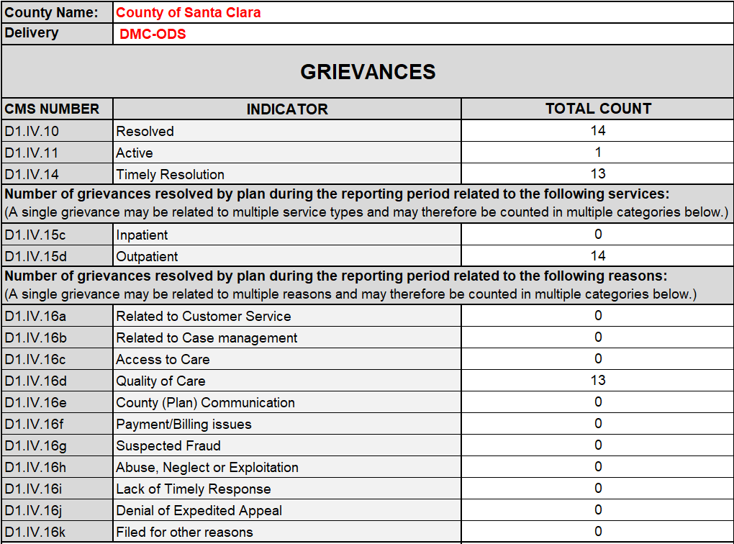

MHP
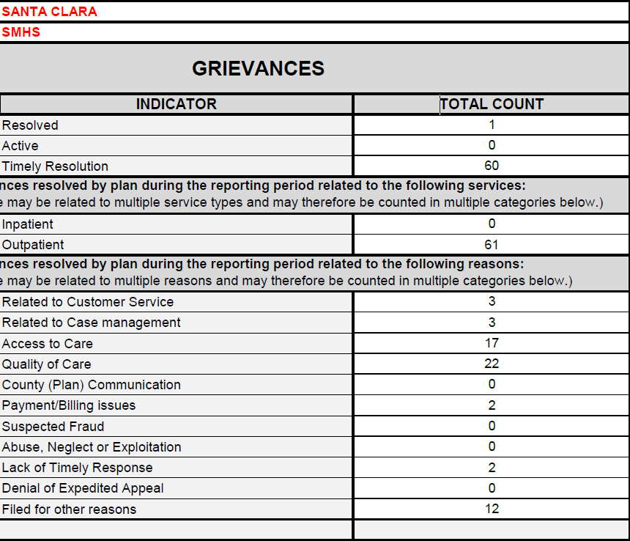

DMC-ODS
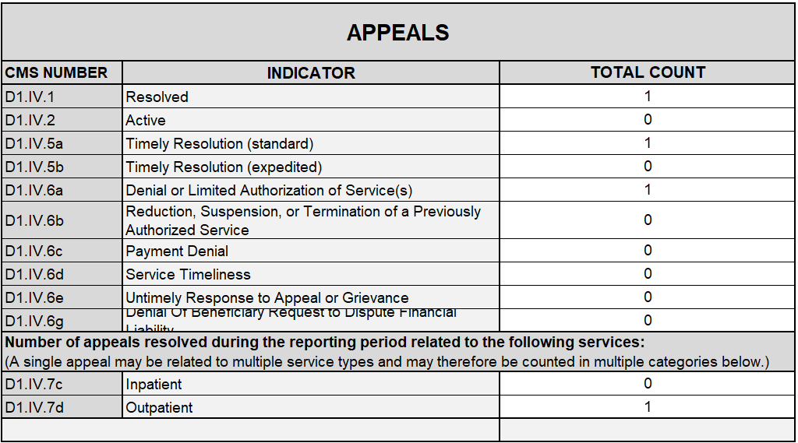

MHP
